MJIIT Scopus Researcher Monitoring Dashboard

  - Prepared by: Tahsin Masnoon Sami
  - Supervisor: Ts. Dr. Liyana 'Adilla Binti Burhanuddin
  - Institution: MJIIT, Universiti Teknologi Malaysia
  - Date: 16/6/2026
  - Website Link: https://mjiit-scopus-project.vercel.app/
  - Github link: https://github.com/TahsinMasnoon08/mjiit-scopus-project

  - Introduction
The MJIIT Scopus Researcher Monitoring Dashboard is a web-based system developed to display researcher profiles, Scopus Author IDs, h-index values, selected papers, and publication records. The system includes a user dashboard, admin dashboard, Supabase database, authentication system, Scopus API integration, backend API endpoints, and Power Automate Desktop automation. The Scopus API is used to import publication data where access is available, while Power Automate Desktop is used as an automation solution to retrieve h-index values and selected paper information directly from Scopus when API access is limited. The backend API connects the website, Supabase database, Scopus data import process, and Power Automate workflow, allowing researcher information and publication records to be updated and displayed through the dashboard.

  - Problem Statement
Researcher publication data and Scopus metrics are usually checked manually. This process takes time, is repetitive, and can become difficult when monitoring many researchers. The system helps centralize researcher data and reduce manual checking by using database storage, API import, and Power Automate automation.

  - System Objectives
1. To develop a web dashboard for displaying MJIIT researcher Scopus information.
2. To allow users to view researcher profiles, h-index, selected papers, and publications.
3. To allow admin users to manage lecturers and publications.
4. To store all researcher and publication data in Supabase.
5. To automate h-index and selected paper updates using Power Automate Desktop.

  - System Users
User:
- Can login
- Can view researchers
- Can search topics/publications
- Can open publication links

Admin:
- Can login
- Can add lecturer
- Can delete lecturer
- Can view all publications by lecturer
- Can delete incorrect publications
- Can access admin dashboard

  - Technology Used
Components | Technology
Frontend | HTML, CSS, JavaScript
Backend | Node.js / Express
Database | Supabase
Hosting | Vercel
Automation | Microsoft Power Automation(Desktop)
External Data Source | Scopus

  - System Architecture
The system architecture of the MJIIT Scopus Researcher Monitoring Dashboard consists of five main components
- User Interface / Frontend
- Backend API Server
- Supabase Database
- Elsevier Scopus API
- Power Automate Desktop Automation
The frontend is used by normal users and administrators to view researcher information, h-index values, selected papers, and publication records. The backend acts as the middle layer that connects the frontend with the database, Scopus API, and automation process. Supabase is used to store researcher profiles, publication data, login details, and updated h-index records.
The system uses the Elsevier Scopus API to retrieve publication data when API access is available. However, because some Scopus information such as h-index and selected papers may require institutional access, Power Automate Desktop is also used as an automation tool. It logs in to Scopus through institutional access, collects the latest h-index and selected paper information, and sends the updated data to the backend API. The backend then updates the Supabase database, and the latest information is displayed on the website.
The system includes a batch file named run_scopus_update.bat, which is used to start the Scopus data update process. When this file is executed, it first starts the backend server and calls the system API to update or import publication data from Scopus into the Supabase database. After the API update process is completed, the batch file then starts the Power Automate Desktop flow. The Power Automate flow opens Scopus, checks researcher profiles, extracts the latest h-index values, identifies the selected papers based on the h-index position, and sends the updated information back to the backend API. The backend API then updates the Supabase database, and the website displays the latest researcher and publication information automatically.

1. Frontend
The frontend is built using HTML, CSS, and JavaScript. It contains:
- Public user dashboard
- Admin dashboard
- Researcher profile cards
- Selected papers display
- Publication list modal
- Login and signup pages
Normal users can view researcher information, while admins can manage researchers and publication records.

2. Backend API
The backend is built using Node.js and Express.js. It handles:
- User login and role checking
- Researcher data retrieval
- Publication data retrieval
- Admin add/delete/update functions
- Scopus API requests
- Power Automate update requests
- Database communication with Supabase

3. Supabase Database
Supabase is used as the cloud database. It stores:
- Researcher details
- Scopus Author ID
- h-index
- Profile URL
- Selected papers
- Publication records
- User accounts
- User roles, such as admin and user

5. Power Automate Desktop
Power Automate Desktop is used as an automation support system. It updates data that cannot be fully retrieved using the API.
It performs tasks such as:
- Opening Scopus website
- Logging in using institutional access
- Searching researcher profile
- Reading h-index
- Sorting publication list
- Selecting the h-index paper and h-index + 1 paper
- Sending updated data to the backend API

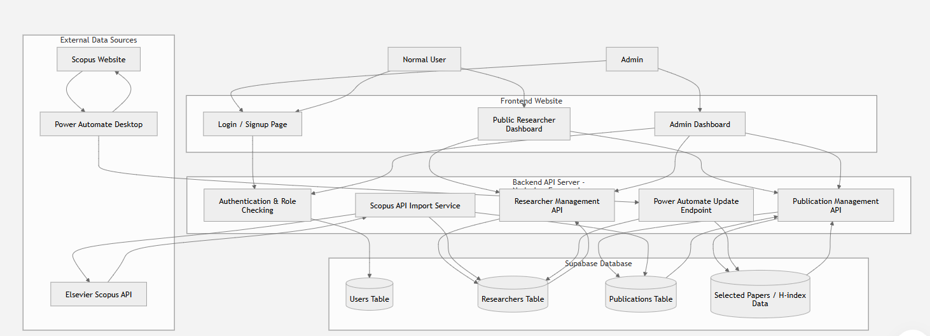
Figure 1 shows the overall architecture of the system, including the frontend website, backend API server, Supabase database, Elsevier Scopus API, and Power Automate Desktop automation.

  - Database Design
The database design of the MJIIT Scopus Researcher Monitoring Dashboard is developed using Supabase. The database stores researcher information, user accounts, publication records, h-index data, and selected papers. The main purpose of the database is to make sure all researcher profiles and publication data can be stored, updated, retrieved, and displayed on both the user dashboard and admin dashboard.
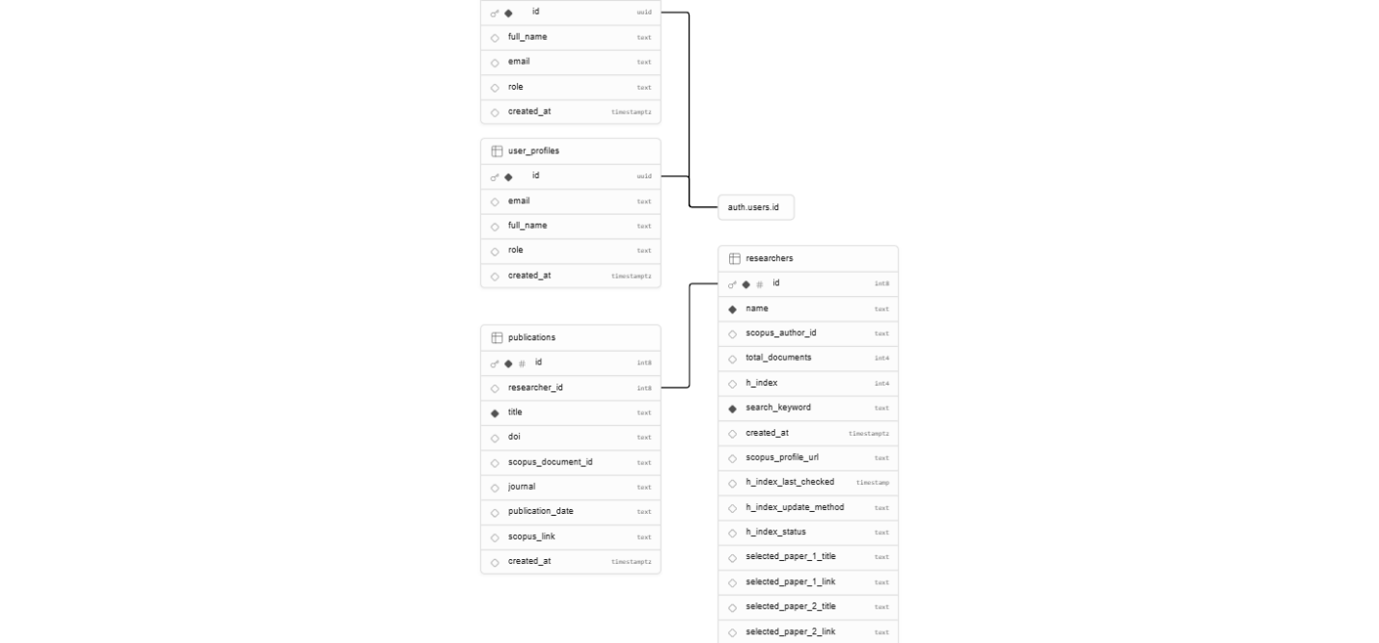
Figure 2 Supabase Database Schema for the MJIIT Scopus Researcher Monitoring Dashboard
  - Website Pages
Login Page
Allows registered users and admins to login. After login, the system checks the user role from user_profiles. Admin users are redirected to admin.html, while normal users are redirected to home.html.

Signup Page
Allows new users to create an account. New accounts are assigned the user role by default. Admin registration need to be done manually in database.
Home Page
Displays researcher information, Scopus Author ID, h-index, selected papers, publication count, and topic/journal search.

Admin Home
Allows admin to manage researchers, view all publications by researcher, delete publications, and delete lecturers from the database.

  - Power Automate Desktop Workflow
1. Power Automate calls the backend API to get the list of researchers.
2. The API returns researcher names and Scopus Author IDs.
3. Power Automate opens Scopus in Microsoft Edge.
4. If Scopus requires login, Power Automate completes the login process.
5. For each researcher, Power Automate opens the Scopus author profile.
6. It extracts the h-index value.
7. It opens the document list.
8. It selects the h-index ranked paper and the next paper.
9. It sends the h-index and selected paper data back to the backend API.
10. The backend updates Supabase.
11. The website displays the updated data automatically.

  - API Endpoints
GET /api/rpa-researchers
Returns all researchers for Power Automate.

POST /api/update-hindex
Receives h-index and selected paper data from Power Automate.

POST /api/import-all-publications
Imports publication data for all researchers.

POST /api/import-publications/:researcherId
Imports publications for a selected researcher.

  - Admin Functions
The admin dashboard allows the admin to add new lecturers using name and Scopus Author ID. The system can auto-generate the Scopus profile URL. Admin can also view all publications under each lecturer and delete incorrect publications. When a lecturer is deleted, connected publications are also removed so the home page stays updated.
Admin Account
E-mail: admin@mjiit.com
Password: admin1234

  - Deployment
The website is deployed using Vercel. Code changes are pushed to GitHub, and Vercel automatically redeploys the latest version from the main branch.

  - System Limitations
1. Scopus API access may be limited due to institutional access restrictions.
2. Power Automate depends on Scopus page layout, so changes in Scopus UI may require flow updates. Changes in layout may fail in automation.
3. Automation requires valid institutional login access to Scopus.
4. Admin needs to manually run automation.

  - Future Improvements
1. Add automatic scheduled update every 15 or 30 days.
2. Add admin approval for new users.
3. Add charts for publication trends.
4. Add export to Excel/PDF.
5. Add better error logging for Power Automate.

  - Conclusion
The developed system provides a centralized platform for monitoring MJIIT researcher Scopus data. It improves accessibility, reduces manual checking, supports admin management, and integrates Power Automate Desktop to update h-index and selected paper information from Scopus.

